Figure-1.1. Verilog Source code for JK Flip-Flop
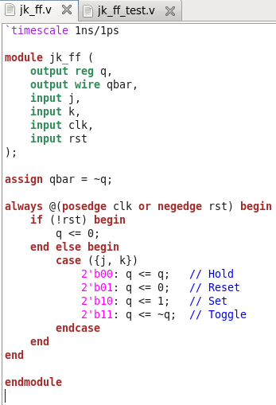

Figure-1.2. Verilog Source code for JK Flip-Flop Test-bench
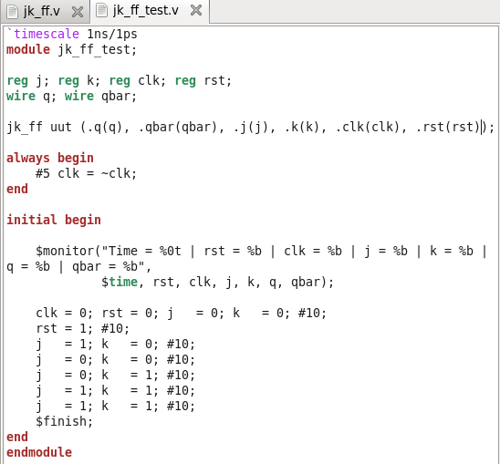

Figure-1.3. NCLaunch window of JK Flip-Flop showing successful compilation (no errors in the Command Entry Window)
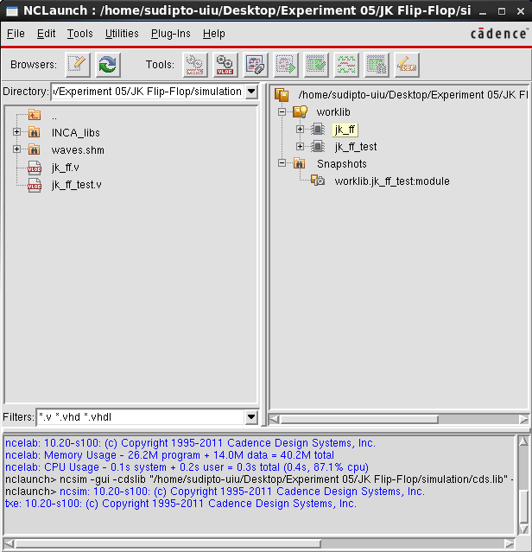

Figure-1.4. SimVision window for JK Flip-Flop Test-bench, showing the inputs, selector lines, and output
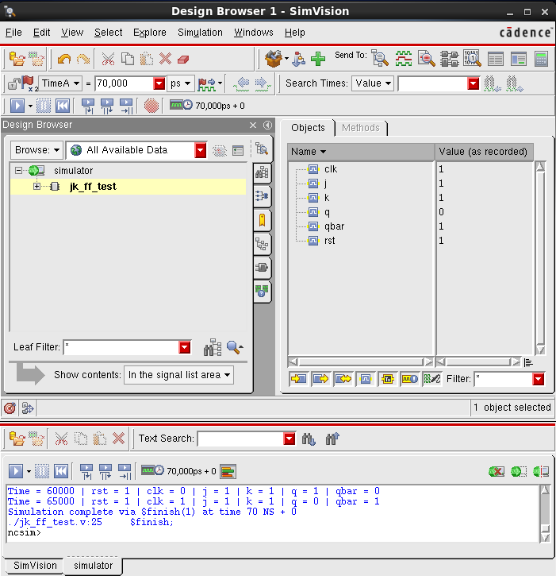

Figure-1.5. SimVision Output Waveform for JK Flip-Flop Test-bench, showing the inputs, selector lines, and output
